Policy for the provision of

Intraoperative Cell Salvage

Author:

Policy ratified by:

Responsible Officer: | Signature
Date | Insert Date

Classification | Clinical | Date Issued
Area Applicable |  | Review Date
Ref No: |  | Version No:

Disclaimer

When using this document please ensure that the version you are using is the current, in date version by checking on your Organisations database for any new versions. If the review date has passed please contact the author.

OUT OF DATE POLICY DOCUMENTS MUST NOT BE USED

Original generic policy written by the UK Cell Salvage Action Group

Guidance

All references to Intraoperative Cell Salvage (ICS), Postoperative Cell Salvage (PCS) and combined systems (ICS/PCS) in this policy, relate to WASHED systems only (unless otherwise stated).

This policy does not relate to the use of unwashed cell salvage systems e.g. postoperative autologous wound drains or combined unwashed ICS/PCS devices.

This policy has been written to support the implementation and use of washed ICS. It may also be applicable when washed ICS devices are used in the pre and/or postoperative environment (e.g. Accident and Emergency, recovery, ward etc) and for devices specifically designed for combined washed ICS/PCS.
Contents

1 | Introduction | Page 3
2 | Policy Statement | Page 4
3 | Aims | Page 5
4 | Objectives | Page 6
5 | Responsibilities | Page 7
6 | Training | Page 9
7 | Indication and Patient Selection | Page 10
8 | Contraindication and Warnings | Page 11
9 | Patient Information | Page 13
10 | Conditions for Use | Page 14
11 | Management of Massive Reinfusion | Page 18
12 | Quality Assurance | Page 19
13 | Adverse Event Reporting | Page 20
14 | Resources | Page 21
15 | Implementation | Page 22
16 | Acknowledgements | Page 23
17 | References | Page 24
Appendix I | Audit Proforma | Page 26
Appendix II | Intra-operative Cell Salvage Competency Assessment Workbook | Page 27
Appendix III | Guidance for the use of Intra-operative Cell Salvage in Obstetrics | Page 28
Appendix IV | “Please Ask About Cell Salvage” Patient Information Leaflet | Page 31
Appendix V | Manufacturers’ Guidelines | Page 32
Appendix VI | Autologous Transfusion Label | Page 33
Appendix VII | Fault Log | Page 34
Appendix VIII | “Will I need a Blood Transfusion?” Patient Information Leaflet | Page 35

1 Introduction

Whilst allogeneic (donated) blood is an essential adjunct to health care, it is an expensive and limited resource (subject to the threat of future shortages), and can present a source of risk for patients, in particular the risk of “wrong blood” incidents as reported by the Serious Hazards of Transfusion (SHOT) steering group¹.

The Health Service Circular (HCS), “Better Blood Transfusion: Safe and Appropriate Use of Blood”, recommends that in order to make transfusion safer, to provide better information for patients relating to transfusion and to avoid the unnecessary use of blood in clinical practice, blood transfusion must be an integral part of NHS care².

The HSC further recommends that effective alternatives to allogeneic blood transfusion be explored, including the appropriate use of autologous blood transfusion techniques such as Intraoperative Cell Salvage (ICS).

ICS is used routinely in some areas of surgical practice. The technique involves aspirating blood lost within the surgical field into a collection reservoir. Blood is mixed with an anticoagulant solution containing either heparin or citrate to prevent clotting. A modified aspiration line is used to deliver the anticoagulant to the tip of the suction. As blood enters the collection reservoir it is filtered to remove large particulate debris. The salvaged blood is then centrifuged and washed to produce red blood cells suspended in saline for reinfusion to the patient. The waste products (plasma, platelets, anticoagulant etc) are removed during processing and the washed red blood cells are transferred to a reinfusion bag. When used appropriately, by adequately trained staff, ICS is a simple, safe and cost-effective method of reducing allogeneic transfusion³⁻⁴.

2 Policy Statement

Utilising appropriate alternatives to blood transfusion is cost-effective and complies with clinical governance requirements.

The collection and re-infusion of autologous red blood cells provides an important contribution to reducing the demand for allogeneic blood. However, it is only one aspect of a strategic approach to safe and appropriate transfusion practice.

3 Aims

The aim of this policy document is to provide information that will allow clinicians to:

- Utilise ICS in a safe and effective manner.

- Safely identify suitable patients undergoing elective and/or emergency surgical procedures where ICS could be used.

4 Objectives

The objectives of this policy are to provide a rational and practical framework on which to maximise patient safety during ICS by:

- Promoting safer transfusion as part of clinical governance responsibilities.

- Assisting clinical staff in the identification of patients and procedures considered suitable for ICS and outlining the indications and contraindications.

- Assisting clinical staff to provide appropriate advice on options for treatment particularly where patients are anxious about risks associated with donor blood.

- Providing clear written information about the risks and benefits of autologous transfusions from blood salvaged intraoperatively.

- Assisting clinical staff to minimise avoidable/potential risks of autologous transfusions from blood salvaged intraoperatively.

5 Responsibilities

The Organisation should define individual responsibilities and identify a clinical lead for the ICS programme.

Responsibilities associated with ICS include:
- Prescribing responsibilities
- Labelling responsibilities
- Individual responsibilities
- Documentation responsibilities

Prescribing Responsibilities
Salvaged blood reinfusion should be prescribed by the responsible clinician on the documentation approved by the Organisation.

Labelling Responsibilities
The reinfusion bag should be labelled as soon as is reasonably practical (i.e. when the patient is in theatre or as soon as the processing set is loaded if a “collect only” system has been used initially). If a “collect only” system has been set up, it is recommended as best practice that the collection reservoir is labelled, this label can then be transferred to the reinfusion bag when the processing set is loaded. The patient details should be handwritten on the label from the patient’s identification band (attached to the patient) and include the following:
- full name
- date of birth
- unique identification number
- expiry date and time of the salvaged blood

Addressograph labels should not be used because of the known associated risks⁵.

Individual Responsibilities
Individual staff should ensure that they are adequately trained and competent in the use of the ICS system and their individual responsibilities according to their area of work, i.e. operator, anaesthetic, scrub, recovery and ward staff. Individual staff should ensure they are adequately trained and competent in the use of ICS in each of the specialities they work in. Staff should not use equipment for which they have not been trained and competency assessed.

Documentation Responsibilities
Staff should ensure that documentation (including all appropriate labelling) accurately reflects the ICS process. The documentation record should include:

- The ICS audit form (Appendix I).

- The autologous transfusion label should be completed and attached to the reinfusion bag.

- At the time of reinfusion of the salvaged blood, the peel out section on the autologous transfusion label should be completed and attached in the appropriate place in the patients’ clinical records or equivalent as specified in the Organisations Transfusion Policy (Policy Document Ref No. for the Organisation’s Transfusion Policy should be entered here).

- Appropriate labelling of heparin saline anticoagulant at the start of the procedure.

- Bedside pre-transfusion checks and patient observations prior to and during ICS blood reinfusion should be performed and recorded in the same way as for the transfusion of allogeneic blood (Policy Document Ref No. for the Organisation’s Transfusion Policy should be entered here). Additional observations are at the discretion of the clinical staff based on an individual patient assessment.

- Adverse incidents should be documented in the patients’ clinical records and reported as in section 13.
6 Training

- Key personnel should be identified in each clinical area as a contact for communication and training. This person will maintain training records of staff who have received training in the use of the ICS device (a copy of this record may be sent to the Transfusion Practitioner or other designated person for central collation).

- Theoretical and practical training should be undertaken and staff should be competency assessed before they set up or operate ICS equipment without supervision.

- Individual staff should receive training in the indications, contraindications and technical differences specific to their speciality/specialities. If a member of staff moves from one speciality to another, it is good practice for training needs to be identified and addressed prior to the staff member using ICS in their new clinical environment.

- Staff carrying out ICS for Jehovah’s Witness patients should have received training and have been competency assessed in preparing the equipment and blood for reinfusion in accordance with the patients’ religious beliefs, prior to carrying out the procedure.

- An ICS Competency Assessment Workbook is available via the Better Blood Transfusion Toolkit at www.transfusionguidelines.org.uk (see also Appendix II). It is strongly recommended that once assessed as competent, individuals keep an ongoing log (similar to that in the ICS Competency Assessment Workbook) of all the ICS procedures they carry out.

- Operators should carry out a minimum of (insert locally agreed figure here) ICS procedures per (insert locally agreed time period here e.g. month, year) in order to ensure competency is maintained.

- Update training is recommended under the following circumstances:

- Any reasonable length of time without practical use of the ICS device.

- A learning need is identified by an individual member of staff or supervisor.

- Changes in the product from the manufacturer or a change in the product due to the Organisation trialling/purchasing new products.

- Changes to national and/or local guidelines relating to any aspect of autologous transfusion (including changes to the Organisation’s Blood Transfusion Policy).

- Competency assessment should be repeated every (insert locally agreed time frame here).

Individual Responsibilities
Individual staff should ensure that they are adequately trained and competent in the use of the ICS system used and their individual responsibilities according to their area of work, i.e. operator, anaesthetic, scrub, recovery and ward staff.

- Indications and Patient Selection

- ICS systems may be used in elective and/or emergency surgical procedures where the surgical field is not contaminated by faecal or infective matter and where no other contraindications exist (see section 8).

- Patient selection for ICS is at the discretion of the surgeon and anaesthetist caring for the patient.

- Providing that none of the contraindications listed in section 8 exist, patients to be considered for ICS include:

- Adult and paediatric patients undergoing elective or emergency surgical procedures where the anticipated blood loss is greater than 20% of the patient’s estimated blood volume⁶.
This will include:
(Individual Organisations should enter the procedures in which ICS may be used here)

- Adult and paediatric patients undergoing elective or emergency surgical procedures who have risk factors for bleeding or low preoperative Haemoglobin levels.

- Patients who have rare blood groups or multiple antibodies for whom it may be difficult to obtain allogeneic blood.

- Patients who, for moral, religious or other reasons, are unwilling to receive allogeneic blood and have given their consent to receiving autologous blood collected using ICS (all such decisions should be documented in the patient’s clinical records). Reference should be made to the patient’s Advanced Medical Directive where one exists.

    - If the surgical procedure to be carried out for patients in 3 and 4 above is associated with any of the contraindications as listed in section 8, the potential risks and hazards should be discussed with the patient and their agreement to undergo ICS documented in the patient’s clinical records.

8 Contraindications and Warnings

The risk/benefit ratio of ICS should be assessed for each individual patient by the surgeon and anaesthetist responsible for the patient’s care.

Contraindications
ICS should not be used in the following situations:

- Bowel contents in the surgical field

- Heparin induced thrombocytopenia when heparin is the anticoagulant of choice (a citrate containing anticoagulant solution may be used instead)

Warnings
- ICS should be temporarily discontinued when substances not licensed for Intravenous (IV) use are used within the surgical field and could potentially be aspirated into the collection reservoir. The standard theatre suction should be used to aspirate the surgical field and the wound should be irrigated with copious IV normal saline (0.9% NaCl) before resuming ICS.

Examples of non-IV materials that should not be aspirated into the ICS system include:
- Antibiotics not licensed for IV use
- Iodine
- Topical Clotting Agents
- Orthopaedic Cement

- The use of ICS in the presence of infection may result in bacterial contamination of the salvaged blood. The aspiration of blood from an infected site should be avoided and antibiotics should be given as appropriate.

- Gastric/pancreatic secretions should not be aspirated into the system as they may cause enzymatic haemolysis and are not reliably removed by the washing procedure.

- Pleural effusions should not be aspirated and should be drained prior to cell salvage. However, blood which subsequently accumulates in the pleural space may be aspirated.

- There are concerns relating to the use of ICS in patients with sickle cell disease. The use of ICS in patients with abnormal red cell disorders should be made on a clinical, individual patient basis taking the latest evidence into account.

  - Amniotic fluid should not be aspirated into the system due to theoretical concerns related to Amniotic Fluid Embolism. See Appendix III for obstetric ICS usage.

  - The use of ICS in patients undergoing surgery for malignant disease is not recommended by the manufacturers of ICS devices. This is due to concern about the possibility of malignant cells being reinfused and giving rise to metastases. However, there are now a number of reports in the literature of the use of ICS in cancer surgery without obviously leading to early metastasis⁷⁻⁹ and some hospitals now use ICS routinely during surgery for malignant disease. Aspiration of blood from around the tumour site should be avoided to minimise contamination of salvaged blood with malignant cells and the salvaged blood may be reinfused through a leukocyte reduction filter to minimise the reinfusion of any malignant cells which may have been aspirated into the collection reservoir.

Guidance on the use of ICS in radical prostatectomy and radical cystectomy is available for the National Institute for Health and Clinical Excellence¹⁰.

The decision to use ICS in the presence of malignant disease should be made by the surgeon and anaesthetist in consultation with the patient.

Cautions
- The use of Hartmann’s Solution will inhibit the action of citrate based anticoagulants (e.g. ACD) if used as an irrigant or wash solution.

- Air will be present in the primary reinfusion bag when it is still connected to the cell salvage device or when it has been disconnected but air has not been evacuated. Where possible, all air should be evacuated from the primary reinfusion bag prior to reinfusion. Manufacturers advise NOT to use a pressure cuff as there is a risk of air embolus and some devices may also detect a back pressure if the reinfusion line is open.

- Manual mode – It is recommended that ICS devices are not run in manual mode as this may lead to reduced quality, insufficient washing of the final red blood cell product and the possible reinfusion of potentially harmful contaminants e.g. heparin. ICS devices should be run in automatic mode wherever possible. Manual mode should only be used when the benefits of doing so outweigh the risks e.g. emergency situations where the need to reinfuse the red cells quickly outweighs the risks associated with running the device in manual mode.
9 Patient Information

- Patients considered likely to have ICS during planned surgery should receive information about ICS before their operation. The process should be discussed with the patient pre-operatively whenever possible and the discussion documented in the patient’s clinical records. Written information may be useful – for example the Patient Information Leaflet “Please Ask About Cell Salvage” (Appendix IV).

- For patients undergoing emergency surgery, the use of ICS is at the discretion of the surgeon and anaesthetist responsible for the patients care when it cannot be discussed with the patient prior to surgery.
10 Conditions for Using ICS

Use of the ICS Equipment
- The ICS system should be used in accordance with the manufacturer’s guidelines (Appendix V).

- All procedures should be carried out in accordance with the hospital’s ICS policy and procedural documents.

- The ICS system should be routinely run in automatic mode (see Cautions - section 8)

- Contraindications should be considered as identified in Section 8.

- All staff who set up or operate ICS systems should receive theoretical and practical training (see section 6) and should have completed the ICS Competency Assessment Workbook (Appendix II).

- Staff should comply with hospital policies for infection control, management of sharps and blood transfusion.

- Clean/non-touch/aseptic technique should be used as appropriate, to reduce the risk of infection.

Anticoagulant
- The type of anticoagulant used should be documented on the cell salvage record for each case (Appendix I).

- Anticoagulant prepared by the operator (e.g. heparin saline) should be labelled clearly to avoid error.

Wash Solution
- IV normal saline (0.9% NaCl) should be used as the wash solution.

- The minimum wash volume, as outlined in the manufacturers’ guidelines (Appendix V) for the size of the centrifuge bowl in use and the type of surgical procedure, should be used in all but the most urgent situations.

Labelling
- All salvaged blood should be labelled.

- Labels should be handwritten. Pre-printed “addressograph” labels should not be used.

  - Labelling information should include:
    - full name
    - date of birth
    - unique identification number
    - expiry date and time of the salvaged blood
    - The statement “Untested Blood – For Autologous Use Only”¹¹

  - To avoid errors in patient identification, an autologous transfusion label such as that in appendix VI should be completed at the patient’s side, when the patient has arrived in theatre i.e. the reinfusion bag should not be pre-labelled prior to the patient’s arrival in theatre or labelled after the patient has left theatre. The patient’s details should be taken from the identification band attached to the patient and not from any clinical records or charts that may be present in the operating theatre. All fields on the label should be completed in full.

  - If the system has been set up as a “collect only” system (collection reservoir and aspiration and anticoagulant line only), the collection reservoir should be labelled in accordance with the above instructions for labelling a reinfusion bag. If a processing set is subsequently loaded into the machine, the autologous label on the collection reservoir should be transferred onto the reinfusion bag immediately or a new label completed (as above).

Re-infusion
Prescribing Responsibilities: Salvaged blood reinfusion should be prescribed by the responsible clinician on the documentation approved by the Organisation.

  - ICS may be set up as a “closed-circuit” system. Blood is aspirated from the surgical field, processed and transferred to a reinfusion bag. The reinfusion bag is simultaneously connected to the patients IV cannula via an appropriate filter (see below). The person administering the reinfusion adjusts the rate at which the red cells are reinfused using a clamp on the administration set and by adjusting the height of the reinfusion bag. A pressure cuff should not be applied to increase the flow rate because of the risk of air embolism. The same reinfusion bag may fill and empty many times during an operation.

  - Alternatively, ICS may be set up without simultaneous connection of the reinfusion bag to the patient (as above). In this case, the reinfusion bag is disconnected from the ICS device when it is full or at the end of the surgical procedure and is subsequently connected and reinfused to the patient as in the “closed-circuit” system.

  - A filter, appropriate to the type of surgery, should be used for reinfusion. A blood administration set containing a 200μm filter is suitable in most cases. Alternatively, a 40μm microaggregate blood filter can be used. It is recommended that a leukocyte depletion filter is used for obstetrics and malignancy cases.. Lipid filters are also available which can be used for orthopaedics.

  - Reinfusion of the salvaged blood should follow standard blood transfusion practice (Policy Document Ref No. for the Organisation’s Transfusion Policy should be entered here). The responsible clinician should prescribe salvaged blood for reinfusion in the same manner as for allogeneic blood.

  - The patient details on the reinfusion bag should be carefully checked against the details on the identification band attached to the patient before connecting the reinfusion bag to the patient. Positive Patient Identification must be confirmed prior to reinfusion commencing.

- The reinfusion of salvaged blood should be documented in the appropriate section of the patient’s clinical record or equivalent as specified in the Organisations Transfusion Policy (Policy Document Ref No. for the Organisation’s Transfusion Policy should be entered here). The autologous transfusion label, as in Appendix VI, contains a peel out section which should be completed at the time of reinfusion and can be used for this purpose.

“Storage”
- ICS blood must not be stored.

  - The reinfusion bag should be kept beside the patient at all times.

  - The reinfusion bag must not be placed into a refrigerator.

Expiry
- The collection, processing and reinfusion of salvaged blood should be completed within the timeframes as recommended by the manufacturer. This should be in accordance with guidance from the American Association of Blood Banks (AABB)¹¹ and the Organisations Transfusion Policy (Policy Document Ref No. for the Organisation’s Transfusion Policy should be entered here).

The AABB Guidelines state the expiry times for cell salvaged blood as follows:
  - Intraoperative Cell Salvage: 4 hours from the completion of processing (applicable for both washed ICS and combined washed ICS/PCS devices during the intraoperative phase).
  - Postoperative Cell Salvage: 6 hours from the start of collection (applicable when intraoperative cell salvage devices are used to salvage blood postoperatively and for combined washed ICS/PCS devices during postoperative cell salvage).

- For ICS, processing should begin as soon as there is sufficient blood in the collection reservoir. The expiry time is calculated as 4 hours from the completion of processing i.e. the time when blood first enters the reinfusion bag.

- For combined washed ICS/PCS devices, two separate expiry times should be recorded using the guidance above. One for blood salvaged intraoperatively and one for blood salvage postoperatively.

- Any blood that has not been transfused within the timeframe specified in the guidelines should be disposed of in accordance with local policy for dealing with liquid biohazardous waste (Policy Document Ref No. should be entered here).

- These time frames are in-use limits and not “shelf life” storage limits. ICS blood must not be stored away from the patient.

Documentation
- The collection and reinfusion of salvaged blood should be accurately documented on an appropriate form such as that in Appendix I.

- The use of a generic autologous transfusion labels is recommended (Appendix VI) - the peel out section of the label is completed and attached to the patient’s clinical record upon reinfusion of the salvaged blood.

- Adverse incidents and serious Adverse Events should be documented/ reported (see Section 13).

- Bedside pre-transfusion checks and patient observations prior to and during autologous blood reinfusion should be performed and recorded in the same way as transfusion of allogeneic blood - in accordance with Organisations Blood Transfusion Policy (Policy Document Ref No. for the Organisation’s Transfusion Policy should be entered here). Additional observations are at the discretion of the clinical staff based on an individual patient assessment.

- The Organisation should ensure that adequate records are retained in all cases where ICS is used.

Disposal of used ICS equipment
- Following use, all ICS disposable equipment should be disposed of in accordance with the Organisations’ Health and Safety Policy for disposable of equipment contaminated with blood (Organisation’s Policy Ref No. should be entered here).

Cleaning and Disinfection of ICS Machines
- Following use, the cell salvage machine should be cleaned in accordance with the manufacturers’ guidance and the Organisations Infection Control Policy (Organisation’s Policy Ref No. should be entered here), including procedures for cleaning equipment following high risk cases.

- Following contamination of the equipment internally, the equipment should be removed from use, identified as a potential biohazard and referred to the manufacturer.

Maintenance of Equipment
  - All ICS equipment should be serviced regularly in accordance with the manufacturer’s recommendations. A maintenance record and fault log (Appendix VII) should be kept for each machine.

11 The Management of Massive Reinfusion

As with the transfusion of large volumes of allogeneic red cells, the return of large volumes of salvaged red blood cells will coincide with the depletion of platelets and clotting factors associated with massive blood loss.

In the event of a massive reinfusion of salvaged red blood cells, it is vital to consider the need for additional appropriate transfusion support e.g. platelets, fresh frozen plasma and cryoprecipitate.

Staff should be alert to a large blood loss into the collection reservoir and report this to the surgeon and/or anaesthetist.
12 Quality Assurance

The Trust should maintain comprehensive quality assurance systems to ensure the provision of a safe, high quality ICS service.

Personnel
The Trust should identify a single individual responsible for ensuring that a safe and effective ICS service is provided. This individual should be responsible for ensuring that quality assurance systems are fully implemented.

The Trust should ensure that competent personnel in sufficient numbers are available to provide the ICS service, including for out of hours cases if applicable. Personnel involved in ICS should have undergone appropriate training (see section 6) and competency assessment (Appendix II). Trusts should maintain training records for all staff involved in the ICS process and it is highly recommended that individuals maintain a case log of all procedures in their own portfolios.

Equipment
All ICS equipment should be appropriately maintained. Maintenance should include both an operator maintenance programme and regular company maintenance visits. Operator maintenance programmes should include the implementation of a documented cleaning and minor checking system and the use of a machine specific fault log (Appendix VII). Company maintenance visits must be carried out by an authorized service engineer who will perform a series of documented maintenance controls and fine tune the device for maximum performance.

Product Quality

The quality of the ICS end product should be monitored on a regular basis for each ICS device in use within the Trust. The procedure for monitoring product quality is outlined in (Enter Organisation’s policy/procedural reference for ICS product quality monitoring here).

13 Adverse Event Reporting

- Technical problems with the ICS should be reported to the manufacturer.

- Serious Adverse Events must be reported to the clinical lead for ICS and the Organisation’s Transfusion Practitioner. Any adverse events relating to the ICS device must be reported in accordance with the Organisations Incident Reporting Policy (Organisations Policy Ref No. should be entered here). Additionally, where appropriate reporting to the relevant external bodies should be undertaken e.g. Serious Hazards of Transfusion (SHOT), Medicine and Healthcare products Regulatory Agency (MHRA), especially if the incident has led to or, were it to occur again, could lead to death, life-threatening illness or injury. Other minor safety or quality incidents (caused by human error) should also be reported as these can help demonstrate trends or highlight inadequate manufacturing or supply systems, or inadequate instructions and/or training¹².

- Adverse events should be documented in the patients’ clinical records.

Examples of Adverse Events include:

- Severe reaction on reinfusion of salvaged blood

- Non-labelling / incorrect labelling of salvaged blood

- Equipment malfunction

- Communication failure leading to inappropriate reinfusion of the salvaged blood e.g. contamination occurred within the surgical field and this was not communicated to the operator/anaesthetist.

Reporting of ICS incidents to SHOT is encouraged. The SHOT data collection form can be downloaded at http://www.shotuk.org/sabre/ . Once completed, this should be forwarded to the Hospital Transfusion Team (insert contact details here).

14 Resources

The provision of safe ICS requires adequate resources for the formal, documented training of all staff who setup or operate the equipment and for the regular maintenance and prompt repair of all ICS equipment.

15 Implementation and Distribution of the Policy

This policy document should be circulated to all relevant personnel and implemented in all areas which may be involved in ICS e.g.

Medical Director
Nursing Director
Consultant Lead for Transfusion
Clinical Lead for ICS
Theatre lead for ICS
Theatre trainer for ICS
Directorate Manager for Theatre
Transfusion Practitioner
Jehovah’s Witness Hospital Liaison

The procedure document will be reviewed at timely intervals and when new information becomes available.

Guidance on and queries relating to the document should be addressed to the Organisation’s clinical lead for ICS (Organisations should insert the name of the clinician responsible for ICS here).

16 Acknowledgements

- Maria Roberts, Transfusion Practitioner, Welsh Blood Service/ Cardiff and Vale NHS Trust for her original Postoperative Cell Salvage procedure document on which this policy has been based¹³

- The members of the UK Cell Salvage Action Group

- Royal Brompton & Harefield NHS Trust – Policy for the provision of Perioperative Red Cell Salvage¹⁴

- St Mary’s NHS Trust – Obstetric Intraoperative Cell Salvage Guidelines¹⁵
17 References

- Serious Hazards of Transfusion (SHOT) Report 2009. http://www.shotuk.org/wp-content/uploads/2010/07/SHOT2009.pdf

- Better Blood Transfusion: The Safe and Appropriate Use of Blood (2007) HSC 2007/001

- Murphy GJ, Rogers CS, Lansdowne WB, Channon I, Alwair H, Cohen A, Caputo M and Angelini GD (2005) Safety, efficacy, and cost of intraoperative cell salvage and autotransfusion after off-pump coronary artery bypass surgery: a randomized trial. J Thorac Cardiovasc Surg; 130(1); 20-8

- James V (2004) A National Blood Conservation Strategy for the NBTC and NBS
http://www.dh.gov.uk/prod_consum_dh/idcplg?IdcService=GET_FILE&dID=26734&Rendition=Web

- British Committee for Standards in Haematology Blood Transfusion Task Force (1999). The administration of blood and blood components and the management of transfused patients. Transfusion Medicine; 9; 227-238.

- British Committee for Standards in Haematology Blood Transfusion Task Force (1997) Guidelines for Autologous Transfusion II. Perioperative Haemodilution and Cell Salvage. British Journal for Anaesthesia; 78; 768-771.

- Gray CL, Amling CL, Polston GR, Powell CR and Kane CJ (2001) Intraoperative cell salvage in radical retropubic prostatectomy. Urology; 58(5); 740-5.

- Nieder AM, Carmack AJ, Sved PD, Kimm SS, Manoharan M and Soloway MS (2005) Intraoperative cell salvage during radical prostatectomy is not associated with greater biochemical recurrence rate. Urology; 65(4); 730-4.

- Nieder AM, Manoharan M, Yang Y and Soloway MS (2007) Intraoperative Cell Salvage during radical cystectomy does not affect long term survival. Urology; 69(5); 881-4.

- National Institute For Health & Clinical Excellence (NICE) (2008) Intra-operative Red Blood Cell Salvage During Radical Prostatectomy of Radical Cystectomy
http://www.nice.org.uk/nicemedia/live/11891/40380/40380.pdf

- American Association of Blood Banks (AABB) (2005) Standards for Perioperative Autologous Blood Collection and Administration (2nd Edition)

- Medicines and Healthcare products Regulatory Authority (MHRA) (2011) Device Bulletin: Reporting adverse incidents and disseminating medical device alerts. DB2011/01
http://www.mhra.gov.uk/home/idcplg?IdcService=GET_FILE&dDocName=CON111568&RevisionSelectionMethod=LatestReleased

- Roberts, M.M. (2006) Procedure for Post-operative Autologous Blood Transfusion Drainage Systems in Adult and Paediatric Patients (Draft). Cardiff and Vale NHS Trust.

- Kelleher, A.A. (2004) Policy for the Provision of Perioperative Red Cell Salvage. Royal Bromptonand Harefield NHS Trust.

- Obstetric Intra-operative Cell Salvage Guidelines (Draft 1). St Mary’s NHS Trust 2006.

Appendix I

Audit Proforma

Example of an Audit Proforma for Intraoperative Cell Salvage (Please substitute the form below with your own local Audit Proforma)

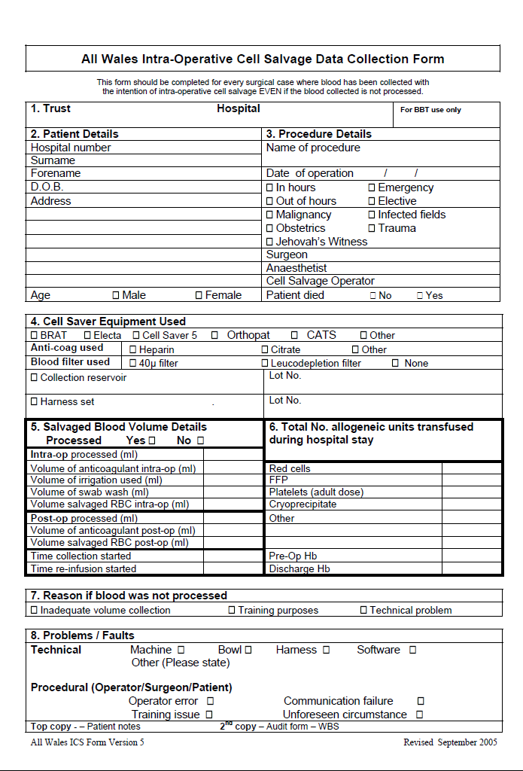
Appendix II

Intra-operative Cell Salvage Competency Assessment Workbook

The Intraoperative Cell Salvage Competency Assessment Workbook is available through the Better Blood Transfusion Toolkit website at:

www.transfusionguidelines.org.uk

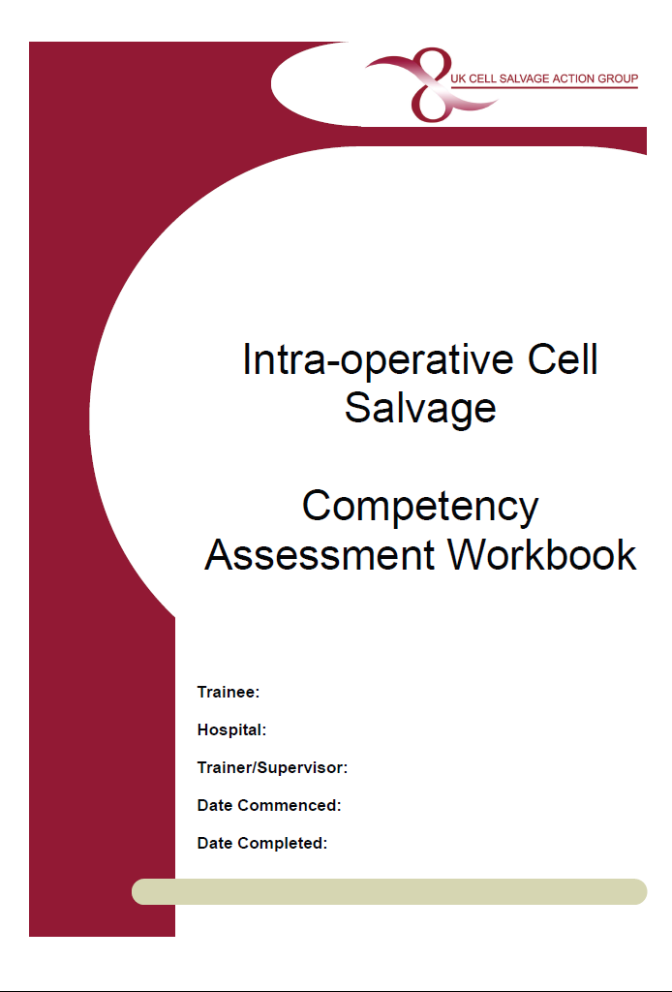

Appendix III

Intraoperative Cell Salvage in Obstetrics

ICS is being increasingly used in the UK in obstetrics for women at risk from post-partum haemorrhage during caesarean section^{i}. In the year 2005-2006, 38% of UK maternity units used ICS, and 28% included the use of ICS in their Massive Obstetric Haemorrhage (MOH) protocol. Early, theoretical concerns over amniotic fluid embolism have not been borne out in clinical practice and 80% of maternity units identified the barrier to more use as lack of training rather than safety concerns

The use of use of ICS in obstetrics has been endorsed by:

- CEMACH^{ii}

- Joint AAGBI/OAA Guidelines^{iii}

- NICE^{iv}

It is strongly recommended that any health care professional involved with obstetric ICS be familiar with all these guidelines.

Patient Selection and Preparation
Wherever possible, the advantages and risks of ICS and allogeneic blood transfusion should be discussed with the patient prior to undergoing an obstetric surgical procedure. In a pre-planned case this can be during the pregnancy. It is recommended that patients receive the NHS Blood and Transplant information leaflet entitled “Will I need a blood transfusion?” (Appendix IX) which contains an “Alternatives to blood transfusion” section and the Intraoperative Cell Salvage Patient Information Leaflet (Appendix IV).

The NICE guidance “Intraoperative blood cell salvage in obstetrics ‘recommends that “whenever possible, the woman understands what is involved and the theoretical risks, and agrees (consents) to have the procedure’^{iv}. When obtaining formal consent for a caesarean section, the obstetrician or anaesthetist should discuss the advantages and risks of ICS with the patient and document clearly the agreement of the patient to undertake the procedure in the woman’s clinical records. As for allogeneic transfusion such detailed consent may not be practicable in an emergency,

Indications for ICS
Patient selection for ICS is at the discretion of the obstetrician and anaesthetist caring for the patient. The type of obstetric cases that should be considered for selection including:

Emergency situations:
- Ruptured ectopic pregnancy
- Post-partum haemorrhage

Elective situations:
- Patients with an anticipated blood loss of >1000mls eg placenta accreta, large uterine fibroids, and other predictable causes of MOH

Other situations:
- Patients who for religious or other reasons refuse allogeneic blood and have consented to the use of ICS in elective or emergency bleeding situations or in significant anaemia.

Additional measures necessary in obstetric ICS:

Amniotic fluid and use of Leukocyte Depletion Filter
Amniotic fluid should ideally not be aspirated into the ICS collection reservoir, but should be removed by separate suction prior to starting cell salvage. This recommendation will reduce the initial contamination, but it should be noted that the in vitro evidence is that the ICS process can effectively remove plasma phase elements of amniotic fluid whatever the initial load^{v}. Therefore, in life-threatening haemorrhage, a clinical decision to use ICS from the start of the procedure should be carefully considered.

After processing, a Pall RS filter (LeucoGuard® RS Leukocyte Reduction Filter, Pall Biomedical Products Co.,East Hills, NY) should be used to reinfuse ICS blood. This is the only filter proved to effectively eliminate residual particulate elements of amniotic fluid^{vi}. It should be remembered that prior to this filter becoming available in 2000, over 250 obstetric cases worldwide were reported to have safely received ICS blood without a problem. Therefore, in life-threatening haemorrhage a clinical decision to reinfuse ICS blood without this filter, and therefore increase the rate at which the blood can be reinfused, should be carefully considered.

Rh immunisation and Kleihauer testing
In any pregnancy involving an Rh negative mother and an Rh positive fetus there is a danger of Rh immunisation if the maternal circulation is exposed to fetal red cells. Antibodies against the fetal red cells can cause haemolytic disease of the newborn in subsequent pregnancies if untreated. Consequently all Rh negative mothers of Rh positive babies will have a Kleihauer performed in the immediate post partum period.

Kleihauer testing is required to establish the amount of fetal red cell exposure and ensures that the mother receives an appropriate dose of Anti-D immunoglobulin (usually 125 iu/ml of fetal blood). Depending on the results of the Kleihauer, a minimum of 500iu Anti-D will be offered in the post partum period to Rh negative mothers with Rh positive babies.

The same protocol should be followed for Rh negative mothers who have undergone reinfusion of ICS blood. The presence of fetal red cells in the ICS blood is likely because the ICS device cannot distinguish fetal from maternal red cells. Depending on the test results it may be that higher doses of Anti-D will need to be administered.

The sample for Kleihauer testing should be taken after the reinfusion of ICS blood and administration of Anti-D should occur within 48- 72 hrs of delivery.

References

    - OAA Survey of UK Maternity Units June 2007

    - Confidential Enquiry into Maternal and Child (CEMACH) (2000-2002). Why Mothers Die - Report on confidential enquiries into maternal deaths in the United Kingdom. Chapter 4 (Haemorrhage) p91-92 Prof Marion Hall

    - OAA/AAGBI (2005) Guidelines for Obstetric Anaesthetic Services revised Edition; p25

    - National Institute For Health & Clinical Excellence (NICE) (2005) Intra-operative Blood Cell Salvage in Obstetrics – Guidance http://www.nice.org.uk/nicemedia/live/11038/30690/30690.pdf

    - Catling S.J., Williams S. and Fielding A.M. (1999) Cell salvage in obstetrics: an evaluation of the ability of cell salvage combined with leucocyte depletion filtration to remove amniotic fluid from operative blood loss at caesarean section. Int J Obs Anesth; 8; 79-84

    - Waters JH. Biscotti C. Potter PS. Phillipson E. (2000) Amniotic fluid removal during cell salvage in the cesarean section patient. Anaesthesiology; 92; 1531-1536.
Appendix IV

“Cell Salvage” Patient Information Leaflet

The following patient information leaflet can be downloaded at:
http://www.transfusionguidelines.org.uk/docs/pdfs/bbt-03-Cell_Salvage_Patient_Information_V5.pdf

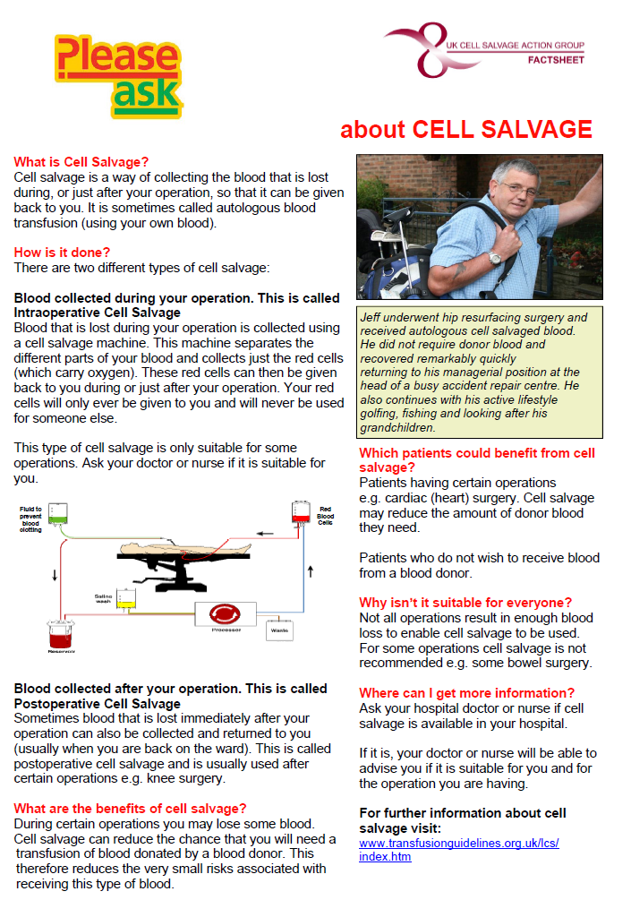
Appendix V

Manufacturers’ Guidelines

The organisation should attach a copy of the Manufacturers’ guidelines to this section
Appendix VI

Autologous Transfusion Label

The following autologous transfusion label is available from your device manufacturer.

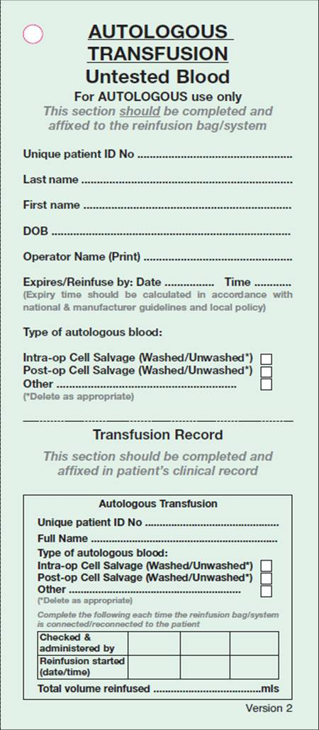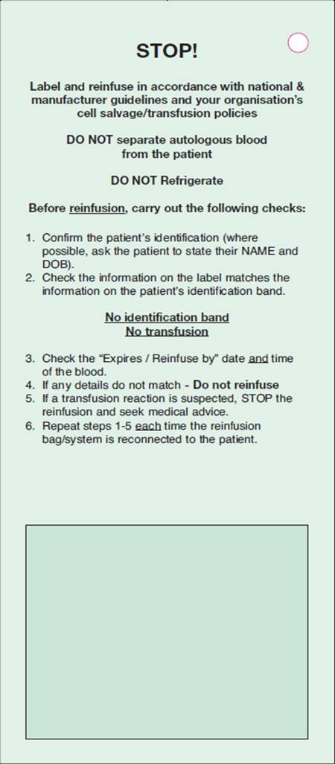

Appendix VII

Fault log
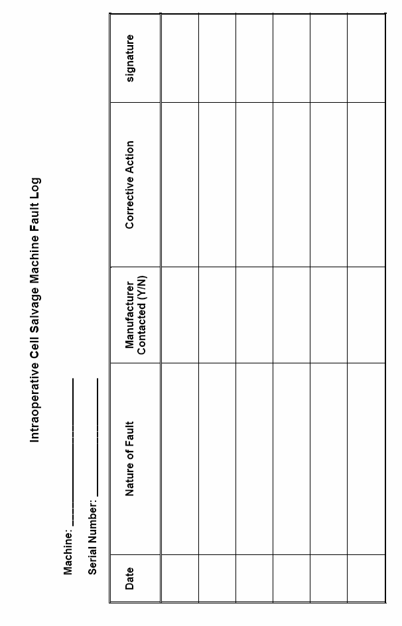
Appendix VIII

NHS Blood and transplant information leaflet entitled “Will I need a blood transfusion”

An order form for the NHS Blood and Transplant information leaflet “Will I need a blood transfusion?” can be downloaded at:

http://hospital.blood.co.uk/library/pdf/PILS_order_form_24_8_11.pdf

Alternatively the leaflet can be downloaded at:

http://hospital.blood.co.uk/library/pdf/2011_Will_I_Need_English_v2.pdf

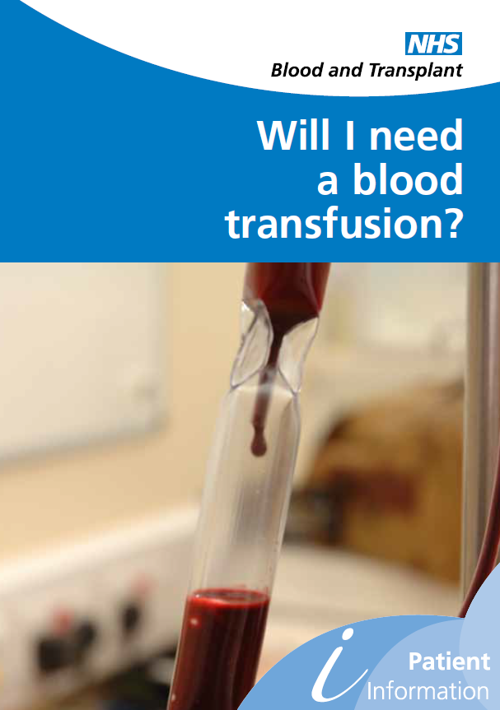

NB. The above leaflet is for hospitals supplied by NHS blood and Transplant, hospitals in Wales, Scotland and Northern Ireland should contact their local blood service for the equivalent leaflet.

